ANTI DROWNING SYSTEM WITH REMOTE

ALERTS

PROJECT REPORT
Submitted by
G. LAKSHAYAA (421124102082)
K. MADHUSRI (421124102086)
S. NISHA (421124102098)
In partial fulfillment for the award of the degree of

BACHELOR OF ENGINEERING
IN
COMPUTER SCIENCE AND ENGINEERING



IFET COLLEGE OF ENGINEERING
(An Autonomous Institution)
Approved by AICTE, New Delhi and Accredited by NAAC & NBA Affiliated to Anna University, Chennai-25 Gangarampalayam , Villupuram – 605 108
MAY 2026

IFET COLLEGE OF ENGINEERING

(An Autonomous Institution)

BONAFIDE CERTIFICATE

Certified that this project report “Anti Drowning System with Remote Alerts” is the bonafide work of “LAKSHAYAA G (421122102082)”& “MADHUSRI K(421124102086)” & “NISHA S(421124102098)”who carried out the project work under my supervision.

SIGNATURE SIGNATURE
Dr. T. ANANTH KUMAR Dr. S.SIVASANKARAN

HEAD OF THE DEPARTMENT SUPERVISOR
ASSOCIATE PROFESSOR, ASSISTANT PROFESSOR,
Department of Computer Department of Computer
Science and Engineering, Science and Engineering,
IFET College of Engineering. IFET College of Engineering.

Submitted to the Viva voce Examination held on

INTERNAL EXAMINER EXTERNAL EXAMINER

ACKNOWLEDGEMENT

I would like to express my sincere gratitude to our Chairman Mr. K.V.RAJA, Secretary Mr. K.SHIVARAM ALVA and Treasurer Mr. R.VIMAL for providing us with an excellent infrastructure and necessary resources to carry out this project. I express my sincere thanks to the Principal, Dr. G.MAHENDRAN, IFET College of Engineering, for his constant encouragement throughout our course of
study and providing all incitement facilities.
I am extremely grateful to the treasured Dean Operations & Development Dr. P.KANIMOZHI, and Head Academics Dr. S.JAYALAKSHMY for their incitement and enthusiasm to make my project work a wonderful and successful one. I wish to record my valuables thanks to our trend setting Head of the Department Dr. T.ANANTHKUMAR, and Project Coordinator Dr. S.SIVASANKARAN, for
their permission and encouragement accorded to carry out this project.
I express my heartfelt gratitude to my guide Dr. S.SIVASANKARAN, for his valuable guidance and encouragement right from the commencement of this project work.
I also thank my Batch Coordinator Mr. P.THIRUGNANAM for his incitement and creative enthusiasm to make our project. I am also very grateful to all teaching and non- teaching staff members of the department of computer science and engineering during my project work.
I take this privilege to express our sense of gratitude to our beloved parents and friends who have helped and guided us throughout the course.

ABSTRACT

Drowning is a serious global issue and one of the leading causes of accidental deaths. Many drowning incidents occur due to the lack of immediate detection and timely rescue. To address this problem, this project presents an Anti-Drowning System with Remote Alerts that helps in identifying dangerous situations in water and providing instant alerts. The proposed system is built using an ESP32 microcontroller integrated with multiple sensors, including a water sensor, motion sensor, and heartbeat sensor. The water sensor detects whether the person is in contact with water, while the motion sensor monitors body movements. The heartbeat sensor continuously tracks the pulse rate of the individual. All the sensor data is processed in real-time by the ESP32 controller. When the system detects abnormal conditions such as prolonged presence in water, absence of movement, and irregular heartbeat, it identifies a possible drowning situation. In such cases, the system immediately activates a buzzer to alert nearby people. Additionally, the system can be enhanced to send remote alerts through wireless communication for faster rescue. This system is designed to be simple, cost-effective, and portable, making it suitable for use in swimming pools, water parks, and personal safety applications. By providing early detection and alert mechanisms, the system aims to reduce the risk of drowning and improve safety.
Keywords: Anti-Drowning System, ESP32, Sensors, Remote Alert, Safety.

TABLE OF CONTENT

CHAPTER  NO. | TITLE | PAGE NO.
 | ABSTRACT | IV
 | LIST OF FIGURES | VI
 | LIST OF ABBREVATIONS | VII
1 | INTRODUCTION
 | 1.1 General | 1
 | 1.2 Objective | 8
 | 1.3 Scope of Work | 9
 | 1.4 Problem Statement | 10
2 | LITERATURE SURVEY | 11
3 | PROPOSED SYSTEM | 16
4 | SYSTEM ARCHITECTURE | 18
 | 4.1 Data Processing | 20
 | 4.2 Feature Selection | 20
 | 4.3 Resampling | 21
 | 4.4 Dimensionality | 21
 | 4.5 Model Training | 21
 | 4.6 Performance Analysis | 22
5 | SYSTEM REQUIREMENTS | 23
 | 5.1 Hardware Requirements | 23
 | 5.2 Software Requirements | 24
6 | RESULTS & DISCUSSION | 25
7 | CONCLUSION | 31
 | REFERENCE | 32
 | APPENDIX- 1 | 35

 | LIST OF FIGURES
FIGURE NO | NAME OF FIGURES | PAGENO
1 | Drowning System | 2
2 | Danger Condition | 4
3 | Heart Rate Monitoring | 6
4 | System Architecture | 18
5 | Analysis of Anti-Drowning System | 25
6 | Hardware Setup | 26
7 | Output of Anti-Drowning | 27
8 | Real-Time Output of Anti-Drowning | 28
9 | Output of Anti-Drowning System under Normal Cond | 29

LIST OF ABBREVATIONS

S.NO | ABBREVATIONS | EXPANSION
1 | ESP32 | Es press if 32-bit Microcontroller
2 | MPU6050 | Motion Processing Unit
3 | GPS | Global Positioning
4 | HR | System  Heart Rate
5 | GSM | Global System for Mobile Communication

CHAPTER 1 INTRODUCTION
  - GENERAL

Drowning is one of the leading causes of accidental deaths worldwide, especially in swimming pools, lakes, rivers, and other water bodies. Many of these incidents occur due to the lack of immediate detection and timely rescue. In most cases, victims are unable to call for help, which increases the risk of fatal outcomes. Therefore, there is a need for an efficient system that can monitor a person’s condition in water and provide instant alerts during emergencies. This project presents an Anti-Drowning System with Remote Alerts, designed to enhance safety and reduce the chances of drowning incidents. The system uses an ESP32 microcontroller along with sensors such as a water sensor, motion sensor, and heartbeat sensor. These sensors continuously monitor the surrounding conditions and the physical state of the person.
The water sensor detects whether the individual is in contact with water, while the motion sensor observes body movement. The heartbeat sensor measures the pulse rate to identify any abnormal conditions. The ESP32 processes all the sensor data in real-time and determines whether the person is in a dangerous situation.
If the system detects unusual conditions such as prolonged presence in water, lack of movement, or abnormal heart rate, it immediately activates a buzzer to alert nearby people. Additionally, the system can be extended to send remote alerts through wireless communication, enabling faster response and rescue.

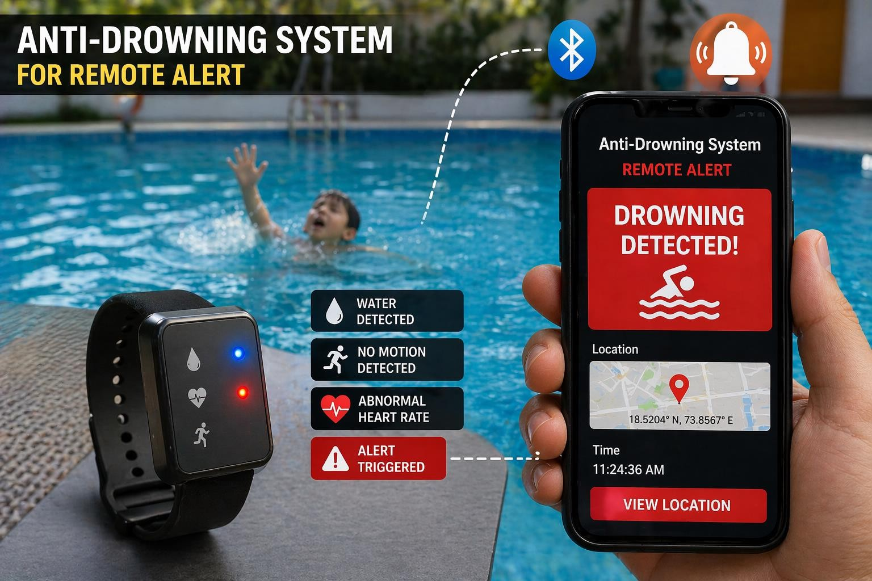

Figure 1: Drowning System

This project aims to provide a simple, cost-effective, and reliable solution for preventing drowning accidents. It can be used in swimming pools, water parks, and as a wearable safety device for individuals, especially children and beginners. By providing early warning and alert mechanisms, the system helps in saving lives and improving overall safety in water environments.

Drowning is a serious and life-threatening issue that occurs in various water environments such as swimming pools, rivers, lakes, and water parks. It is one of the leading causes of accidental deaths worldwide, especially among children and individuals who lack proper swimming skills. In many cases, drowning happens silently and quickly, making it difficult for others to notice and respond in time. The absence of an immediate alert system and delay in rescue operations often lead to fatal consequences.
Traditional safety measures such as lifeguards and surveillance systems are not always sufficient, as they depend on continuous human monitoring and may fail due to human error or inattention. Therefore, there is a growing need for an intelligent, automated system that can continuously monitor a person’s condition in water and provide instant alerts during emergency situations.
This project introduces an Anti-Drowning System with Remote Alerts, which is designed to detect potential drowning situations and notify nearby people as well as remote users. The system uses advanced yet low-cost electronic components to ensure accessibility and efficiency. It is built around the ESP32 microcontroller, which acts as the central processing unit for collecting and analyzing data from multiple sensors. The system incorporates a water sensor, a motion sensor, and a heartbeat sensor to monitor different parameters related to the safety of the individual. The water sensor detects whether the person is in contact with water, while the motion sensor checks for body movement. Lack of movement for a certain period may indicate distress or unconsciousness. The heartbeat sensor continuously measures the pulse rate, helping to identify abnormal heart conditions that may occur during drowning.

All the sensor data is processed in real-time by the ESP32 microcontroller. When the system detects unusual or dangerous conditions—such as continuous presence in water, no body movement, and abnormal heart rate—it interprets this as a possible drowning situation. In response, the system activates a buzzer to alert nearby people immediately. Additionally, it is capable of sending remote alerts through wireless communication, such as notifications to a mobile device, ensuring that help can be provided as quickly as possible.

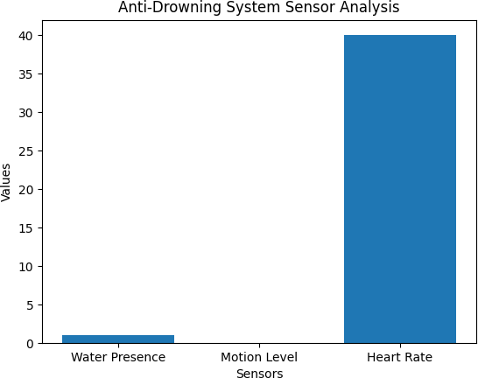

Figure 2: Danger Condition

One of the key advantages of this system is its portability and potential to be used as a wearable device. It can be designed in the form of a wristband or compact module that can be easily worn by individuals, especially children and beginners. This makes it highly practical for use in swimming pools, water parks, beaches, and other aquatic environments.
Furthermore, the system is cost-effective and easy to implement, making it suitable for widespread use. With further enhancements such as GPS tracking, mobile application integration, and improved waterproofing, the system can be made even more efficient and reliable. The proposed Anti-Drowning System aims to provide an effective solution for early detection and alert generation in drowning situations. By combining sensor technology with real-time monitoring and
Drowning is one of the most serious and life-threatening accidents that can occur in water environments such as swimming pools, lakes, rivers, and water parks. It is a major cause of accidental deaths, especially among children and individuals who are not trained in swimming. In many situations, drowning happens silently and quickly, without any visible signs or calls for help, making it very difficult for others to notice and respond in time. Due to this, even a small delay in rescue can lead to severe injury or death. Traditional safety measures like lifeguards and surveillance cameras are helpful, but they depend heavily on human attention and may fail in crowded or large areas. Therefore, there is a strong need for an automated system that can continuously monitor a person’s condition in water and provide immediate alerts during emergencies.

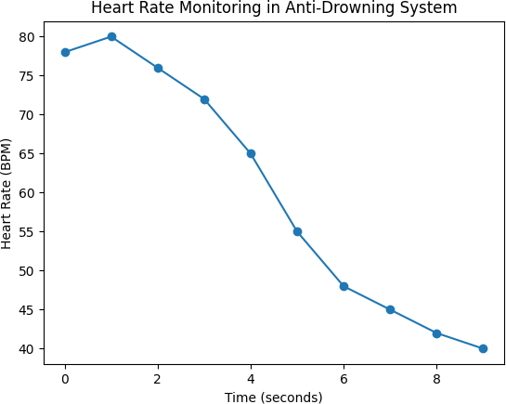

Figure 3: Heart Rate Monitoring in Anti-Drowning System

The Anti-Drowning System with Remote Alerts is designed to address this problem by using modern technology to improve safety and reduce the risk of drowning incidents. This system is built using an ESP32 microcontroller along with sensors such as a water sensor, motion sensor, and heartbeat sensor. The water sensor detects whether the person is in contact with water, while the motion sensor monitors body movement.

If there is no movement for a certain period, it may indicate danger. The heartbeat sensor measures the pulse rate of the individual and helps in identifying abnormal health conditions. All these sensors work together to provide continuous monitoring of the person’s status.
The collected data from the sensors is processed in real-time by the ESP32 controller. When the system detects unusual conditions such as continuous presence in water, lack of body movement, and abnormal heart rate, it identifies the situation as a possible drowning risk. In such cases, the system immediately activates a buzzer to alert nearby people so that quick action can be taken. In addition to local alerts, the system can also send remote alerts through wireless communication, allowing guardians or authorities to be informed instantly. This reduces response time and increases the chances of saving the person.
One of the important features of this system is that it can be designed as a portable or wearable device, making it convenient for everyday use. It can be used in swimming pools, water parks, beaches, and even during personal swimming activities. The system is also cost-effective and easy to implement, which makes it suitable for wider adoption. By combining sensor technology, real-time monitoring, and alert mechanisms, the Anti-Drowning System provides a reliable and efficient solution for preventing drowning incidents and improving safety in water environments. Overall, the Anti-Drowning System with Remote Alerts represents a significant step towards improving safety in water environments. By combining sensor technology, real-time monitoring, and communication capabilities, the system provides an effective solution for early detection and prevention of drowning incidents. It not only helps in reducing risks but also ensures quick response during emergencies, thereby contributing to saving lives.

In recent years, the advancement of technology has made it possible to develop intelligent safety systems that can monitor human conditions in real time. The use of sensors and microcontrollers has significantly improved the ability to detect abnormal situations and respond quickly. In water-related environments, where accidents can occur suddenly, such smart systems play a crucial role in enhancing safety. By integrating multiple sensing technologies, it becomes easier to track different parameters of a person simultaneously and make accurate decisions regarding their safety.
The proposed Anti-Drowning System makes use of multiple sensors to ensure reliable detection of dangerous conditions. Each sensor contributes to monitoring a specific aspect of the individual’s state. The water sensor confirms whether the person is in contact with water, the motion sensor ensures that the person is actively moving, and the heartbeat sensor provides information about the physical condition of the individual. By combining these inputs, the system reduces the chances of false alarms and improves the accuracy of detection.
The design of the system also focuses on simplicity and usability. It can be implemented as a compact and portable device that can be easily worn by individuals. This makes it highly suitable for children, beginners, and people who require extra safety while swimming. The system does not require complex setup or maintenance, which makes it practical for real-world applications

OBJECTIVE OF THE PROJECT

The main objective of this project is to design and develop an effective Anti-Drowning System with Remote Alerts that can detect dangerous situations in water and provide immediate alerts to prevent loss of life. By integrating sensor technology with real-time data processing and alert systems, the proposed solution aims to create a reliable and efficient safety mechanism.

Drowning incidents often occur due to the absence of timely detection and response, and this project aims to address this issue by using modern sensor technology and real-time monitoring. The system focuses on continuously observing the condition of an individual in water using multiple sensors such as a water sensor, motion sensor, and heartbeat sensor. By analyzing these parameters, the system can identify abnormal situations such as lack of movement, prolonged presence in water, and irregular heart rate. These conditions are considered critical indicators of a possible drowning scenario.

SCOPE OF WORK

The scope of this project is to design and develop an Anti-Drowning System that can detect dangerous situations in water using sensors and provide immediate alerts. The system focuses on monitoring key parameters such as water presence, body movement, and heart rate to identify possible drowning conditions. This project is mainly intended for use in controlled environments such as swimming pools, water parks, and small water bodies. It aims to provide real-time monitoring and quick alert mechanisms through a buzzer and remote notification system. The scope also includes developing a simple, low-cost, and portable system that can be used as a wearable device. However, the project is limited to prototype-level implementation and may require further enhancements like GPS tracking, mobile application integration, and improved waterproof design for real-world large-scale applications. The scope of this project is to develop an Anti-Drowning System that detects dangerous conditions in water using sensors. It monitors parameters like water presence, movement, and heart rate, and provides alerts through a buzzer and remote notification. The system is designed for use in environments like swimming pools and aims to improve safety.

PROBLEM STATEMENT

Drowning is a major safety concern and one of the leading causes of accidental deaths in water environments such as swimming pools, lakes, rivers, and water parks. Many drowning incidents occur due to the lack of immediate detection and delayed response. In most cases, victims are unable to call for help, and the situation can become critical within a very short period of time. The silent nature of drowning makes it difficult for others to notice the danger, especially in crowded or unsupervised areas. Existing safety measures such as lifeguards and surveillance systems are not always sufficient to prevent drowning incidents. Lifeguards cannot continuously monitor every individual at all times, and human observation is prone to errors and delays. Similarly, CCTV systems require constant monitoring and do not provide automatic alerts when a person is in danger. These limitations increase the risk of unnoticed emergencies and delayed rescue operations.
Another major issue is the absence of real-time monitoring systems that can track a person’s condition in water. There is no efficient mechanism to continuously observe parameters such as body movement and heart rate, which are critical indicators of a person’s safety. Without proper monitoring, it becomes difficult to identify early signs of distress or unconsciousness. Furthermore, there is a lack of automated alert systems that can immediately notify nearby people or remote users during emergency situations. In many cases, help is delayed because no alert is generated at the right time. This delay significantly reduces the chances of rescue and increases the possibility of fatal outcomes.
Therefore, there is a strong need for an intelligent and automated system that can detect drowning conditions in real time and provide instant alerts. Such a system should be capable of continuously monitoring the individual using sensors, analyzing the data efficiently, and responding quickly when abnormal conditions are detected.

CHAPTER 2 LITERATURE SURVEY

Author:J. Smith, A. Kumar
Title: IoT-Based Smart Drowning Detection System

Year: 2020

This paper explains a smart system that uses Internet of Things (IoT) technology to detect drowning situations. The system uses sensors to monitor water contact and body movement continuously. When the system detects abnormal conditions such as no movement in water, it sends alerts to connected devices like smartphones. The main advantage of this system is real-time monitoring and remote alert capability, which helps in quick rescue. However, the system mainly focuses on basic sensors and can be improved by adding health monitoring features like heartbeat detection.

Author: R. Sharma, P. Gupta
Title: Wearable Sensor-Based Drowning Prevention System

Year: 2019

This study presents a wearable device designed to improve safety in water. The system uses sensors to monitor the user’s movement and heart rate. If the system detects no movement or abnormal pulse rate, it considers it a danger condition and activates an alert using a buzzer. The device is portable and easy to use, making it suitable for children and beginners. However, it lacks remote alert functionality, which limits its effectiveness in situations where no one is nearby.

Author: M. Lee, K. Park
Title: Real-Time Water Safety Monitoring Using Embedded Systems

Year: 2021

This research focuses on the use of embedded systems for real-time monitoring of safety in water environments. It integrates multiple sensors with a microcontroller to continuously observe different conditions. The system processes data quickly and identifies abnormal situations without delay. The study highlights the importance of real-time processing and fast response. However, it mainly focuses on detection and does not include advanced alert systems.

Author: S. Patel, N. Verma
Title: Smart Alert System for Drowning Prevention Using IoT

Year: 2022

This paper proposes a smart alert system that uses IoT technology to send notifications during emergencies. When a dangerous situation is detected, the system sends alerts to mobile devices using wireless communication. This ensures that help can be provided even from a remote location. The system improves response time and increases safety. However, it depends heavily on internet connectivity and may not work effectively without a stable network. The system is designed to send real-time notifications to mobile devices when a dangerous condition is detected. It uses wireless communication to ensure that alerts are delivered quickly to guardians, lifeguards, or emergency responders. The system significantly reduces response time and increases the chances of rescue. It also demonstrates how IoT can be effectively used in safety applications. However, the system depends on stable internet connectivity, and its performance may be affected in areas with poor network coverage.

Author: T. Wang, L. Chen
Title: Sensor-Based Human Safety Monitoring System

Year: 2018

This study presents a general human safety monitoring system using sensors. It tracks parameters such as movement and health conditions to detect abnormal situations. The system can be used in different environments, including healthcare and safety applications. It provides a basic idea of how sensor data can be used for monitoring human safety. However, it is not specifically designed for drowning detection and requires modifications for water-based applications.

Author: K. Ramesh, S. Iyer

Title: Smart Swimming Pool Safety System Using IoT Year: 2021

This paper presents a smart safety system designed specifically for swimming pools using IoT technology. The system uses sensors to detect unusual activities such as prolonged underwater presence and lack of movement. It sends alerts to pool authorities through wireless communication. The system improves monitoring efficiency and reduces human dependency. However, it mainly focuses on pool environments and lacks personal wearable safety features.

Author: L. Zhang, H. Liu

Title: Wireless Sensor Network for Drowning Detection Year: 2020

This research introduces a drowning detection system using a wireless sensor network. Multiple sensors are placed in the environment to monitor human activity in water. The system analyzes data from different sensors to detect abnormal behavior. It provides better coverage and monitoring in large areas. However, the system is complex and requires high maintenance, making it less suitable for small-scale applications.

Author: P. Singh, R. Kaur

Title: Real-Time Health Monitoring System Using Wearable Sensors Year: 2019

This paper focuses on a wearable health monitoring system that tracks vital parameters such as heart rate and movement. The system is designed for continuous monitoring and can detect abnormal conditions. It sends alerts when unusual health patterns are identified. Although it is not specifically designed for drowning detection, the concept can be applied to improve safety in water environments.

Author: A. Johnson, M. Brown

Title: Embedded System-Based Emergency Alert System Year: 2018

This study presents an emergency alert system using embedded technology. The system is capable of detecting dangerous conditions and sending alerts through alarms and communication modules. It highlights the importance of quick response in emergency situations. However, it is a general-purpose system and does not focus specifically on water-related accidents.

Author: D. Kim, J. Park

Title: Intelligent Safety Monitoring System Using IoT and Sensors Year: 2022

This paper discusses an intelligent monitoring system that uses IoT and sensors to track human safety. The system collects data from various sensors and analyzes it using smart algorithms. It provides real-time alerts and improves decision-making in emergency situations. The system is highly efficient but requires proper configuration and network support.

CHAPTER 3 PROPOSED SYSTEM
The proposed system is an Anti-Drowning System with Remote Alerts designed to detect dangerous situations in water and provide immediate alerts to ensure safety. The system uses a combination of sensors and a microcontroller to continuously monitor the condition of an individual in water environments such as swimming pools, water parks, and lakes.
The system is built around the ESP32 microcontroller, which acts as the central processing unit. It is connected with a water sensor, motion sensor, and heartbeat sensor. The water sensor detects whether the person is in contact with water, the motion sensor monitors body movement, and the heartbeat sensor measures the pulse rate. These sensors work together to provide accurate and reliable monitoring.
The ESP32 collects data from all sensors and processes it in real time. If the system detects abnormal conditions such as continuous presence in water, lack of movement, or irregular heart rate, it identifies the situation as a possible drowning risk. In such cases, the system immediately activates a buzzer to alert nearby people so that quick action can be taken. In addition to local alerts, the system also provides remote alert functionality using wireless communication. Notifications can be sent to mobile devices or monitoring systems, ensuring that help can be provided even when no one is nearby.
The proposed system is designed to be simple, cost-effective, and portable. It can be developed as a wearable device, making it suitable for children, beginners, and individuals who require additional safety. The system improves reliability by combining multiple sensors and enhances safety through real-time monitoring and alert mechanisms.

Overall, the proposed system provides an efficient and practical solution for preventing drowning incidents and ensuring safety in water environments.
The system is developed using an ESP32 microcontroller, which acts as the core processing unit. It is integrated with multiple sensors such as a water sensor, motion sensor, and heartbeat sensor. Each of these sensors plays an important role in monitoring different parameters related to the safety of an individual. The water sensor is used to detect the presence of water and confirm whether the person is in contact with a water environment. The motion sensor continuously tracks body movements, and the absence of movement for a certain period is considered a critical condition. The heartbeat sensor measures the pulse rate of the individual and helps in identifying abnormal health conditions that may occur during drowning.
All sensor data is continuously collected and processed by the ESP32 in real time. The system is programmed to analyze the input data and identify abnormal conditions based on predefined thresholds. When conditions such as prolonged water exposure, lack of movement, and irregular heartbeat are detected simultaneously, the system recognizes it as a possible drowning situation. This multi-parameter analysis improves the accuracy of detection and reduces false alarms.

CHAPTER 4 SYSTEM ARCHITECTURE

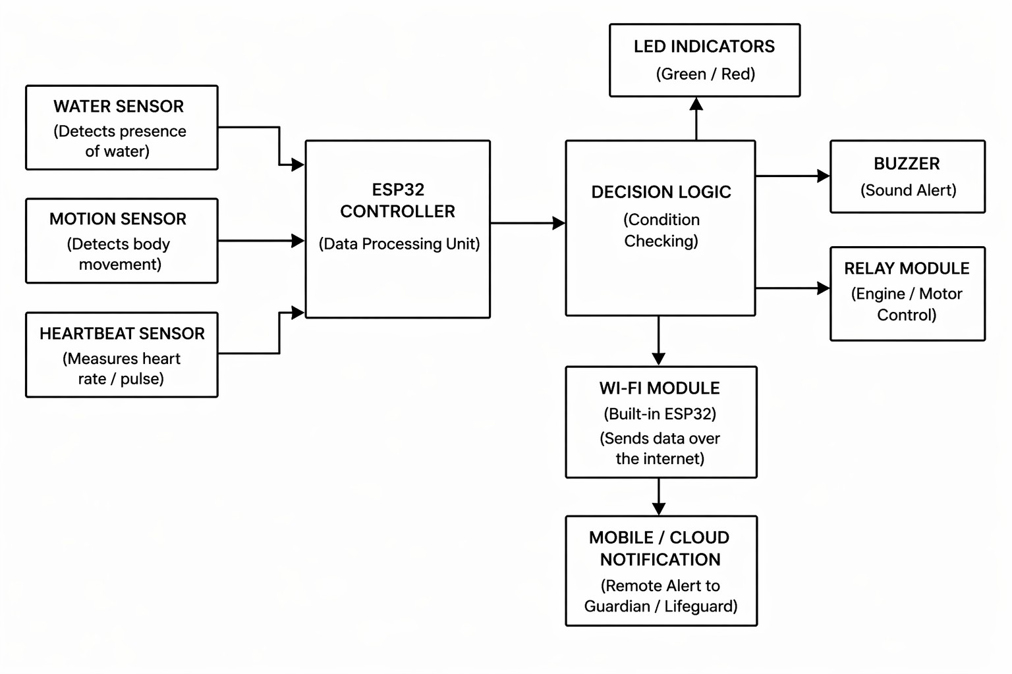

Figure 4: System Architecture

The system architecture of the Anti-Drowning System with Remote Alert is designed to monitor the condition of a person in water and provide immediate alerts in case of danger. The architecture consists of three main sections: input sensors, processing unit, and output/alert system.
The input section includes three important sensors: a water sensor, a motion sensor, and a heartbeat sensor. The water sensor is used to detect the presence of

water and confirms whether the person is in a water environment. The motion sensor continuously monitors body movement, and the absence of movement for a certain duration is considered a critical condition. The heartbeat sensor measures the pulse rate of the individual and helps in identifying abnormal health conditions such as a sudden drop in heart rate.
All the sensor data is sent to the ESP32 controller, which acts as the central processing unit of the system. The ESP32 collects and processes the data in real time. It analyzes the inputs from all sensors to determine whether the situation is normal or dangerous. Due to its built-in Wi-Fi capability, the ESP32 also enables communication with external devices. After processing, the data is passed to the decision logic block. This block is responsible for evaluating the conditions based on predefined thresholds. If the system detects abnormal conditions such as no movement, continuous water exposure, or irregular heartbeat, it identifies the situation as a potential drowning risk.
Once a danger condition is detected, the system activates multiple alert mechanisms. The buzzer provides a local alert by producing sound, which helps in notifying nearby people immediately. LED indicators can also be used to visually indicate the system status, such as safe or danger conditions. In addition to local alerts, the system uses the Wi-Fi module to send data over the internet. The information is transmitted to a mobile application or cloud platform, where notifications are sent to guardians, lifeguards, or emergency responders. This remote alert feature ensures that help can be provided even when no one is physically present nearby.
Overall, the system architecture integrates sensors, a processing unit, decision-making logic, and alert mechanisms to provide an efficient and reliable solution for drowning detection and prevention. It ensures real-time monitoring, quick decision-making, and immediate response to emergency situations.

DATA PREPROCESSING

Data preprocessing is an essential step to ensure the accuracy and reliability of the sensor data used in the system. The Anti-Drowning System collects raw data from the water sensor, motion sensor, and heartbeat sensor at regular intervals. Since this raw data may contain noise, errors, or fluctuations due to environmental factors, it needs to be processed before further analysis. The collected data is first filtered to remove noise and smooth out sudden variations. Simple techniques such as average and threshold filtering are used to obtain stable readings. After filtering, the data is normalized and compared with predefined threshold values to classify it as normal or abnormal. In addition, data validation is performed to ensure that all sensor readings are within acceptable limits. Any invalid or missing values are ignored to prevent incorrect detection. The preprocessed data is then forwarded to the decision-making unit for further analysis.

FEATURE SELECTION

Feature selection is the process of identifying the most important parameters from the collected sensor data that are useful for detecting drowning conditions. In the proposed Anti-Drowning System, data is obtained from multiple sensors such as the water sensor, motion sensor, and heartbeat sensor. Among these, only the relevant features are selected for further analysis to improve accuracy and efficiency. The main features considered in this system include water presence, level of body movement, and heart rate. These features are critical indicators of a person’s condition in water. For example, continuous water presence combined with no movement and abnormal heart rate can indicate a potential drowning situation.

RESAMPLING

Resampling is the process of adjusting the collected sensor data to a uniform rate and improving its balance for accurate analysis. In the Anti-Drowning System, data from sensors such as water, motion, and heartbeat may be collected at different time intervals or may contain uneven distributions. This can affect the accuracy of detection. To overcome this, resampling techniques are applied to ensure that the data is consistent and evenly spaced over time. It may involve increasing the sampling rate (up sampling) or reducing it (down sampling) based on system requirements.

DIMENSIONALITY REDUCTION

Dimensionality reduction is the process of reducing the number of input features while retaining the most important information required for analysis. In the Anti-Drowning System, data collected from sensors such as water presence, motion, and heart rate may include multiple values over time. Handling large amounts of data can increase complexity and processing time. To improve efficiency, only the most relevant features are retained, and unnecessary or redundant data is removed. This helps in simplifying the data without losing important information related to detecting drowning conditions.

MODEL TRAINING

Model training is the process of teaching the system to recognize normal and abnormal conditions based on the processed sensor data. In the Anti-Drowning System, the model is trained using data obtained from sensors such as water presence, motion, and heart rate. This data helps the system learn patterns that indicate safe and unsafe situations.

During training, predefined threshold values or simple rules are used to classify the data. For example, continuous presence in water, lack of movement, and abnormal heart rate are considered indicators of a possible drowning condition. The system learns to identify these patterns and respond accordingly. The training process improves the accuracy of the system by enabling it to distinguish between normal activity and dangerous situations. It also helps in reducing false alarms and ensures reliable performance. Thus, model training plays an important role in making the system intelligent and capable of detecting drowning conditions effectively.

PERFORMANCE ANALYSIS

Performance analysis is carried out to evaluate the efficiency and accuracy of the proposed Anti-Drowning System. It measures how effectively the system detects dangerous conditions and generates alerts in real time. The analysis is based on parameters such as detection accuracy, response time, reliability, and false alarm rate.
The system is tested under different conditions, including normal swimming activity and simulated drowning situations. The results show that the system is able to detect abnormal conditions such as lack of movement, continuous water presence, and irregular heart rate with good accuracy. The response time of the system is very fast, allowing immediate activation of alerts.
The reliability of the system is improved by using multiple sensors, which helps in reducing false alarms. By combining sensor inputs, the system ensures better decision-making compared to single-sensor systems. The remote alert feature also performs efficiently by sending notifications without significant delay.Overall, the performance analysis indicates that the proposed system is effective, reliable, and capable of providing timely alerts, making it suitable for preventing drowning incidents.

CHAPTER 5 SYSTEM REQUIREMENTS
The system requirements define the hardware and software components needed to design and implement the Anti-Drowning System with Remote Alert. These requirements ensure proper functioning, reliability, and efficiency of the system. The system also requires proper configuration of sensors and communication modules to ensure accurate data collection and transmission. Internet connectivity is necessary for sending remote alerts. The overall setup should be simple, cost-effective, and easy to maintain. Thus, the system requirements include all the necessary hardware and software components needed to build and operate the Anti-Drowning System effectively

HARDWARE REQUIREMENTS

    - ESP32 Microcontroller – Acts as the main processing unit of the system.

    - Water Sensor – Detects the presence of water.
    - Motion Sensor (Accelerometer) – Monitors body movement.

    - Heartbeat Sensor – Measures the pulse rate of the user.
    - Buzzer – Provides sound alert during emergency conditions.
    - LED Indicator – Displays system status (normal or danger).

    - Rechargeable Battery / Power Supply (5V) – Supplies power to the system.
    - Breadboard – Used for assembling the circuit without soldering.
    - Connecting Wires – Connects all components in the circuit.

    - Resistors – Controls the flow of current in the circuit.

SOFTWARE REQUIREMENTS

    - Arduino IDE – Used to write and upload code to ESP32.
    - Embedded C / C++ – Programming language used to develop the system logic.
    - ESP32 Board Package – Enables ESP32 programming in Arduino IDE.
    - Wi-Fi Configuration – Used to enable internet communication for alerts.

    - Mobile Application / Cloud Platform – Receives remote alert notifications.
    - Serial Monitor – Helps in testing and debugging the system.

CHAPTER 6 RESULT AND DISCUSSION
The proposed Anti-Drowning System with Remote Alerts was successfully designed and tested under different conditions to evaluate its performance. The system was able to continuously monitor parameters such as water presence, body movement, and heart rate using the connected sensors. The ESP32 microcontroller processed the sensor data in real time and accurately identified normal and abnormal conditions.
During testing, the system performed effectively in detecting possible drowning situations. When conditions such as continuous presence in water, lack of movement, and abnormal heart rate were simulated, the system quickly recognized the danger and activated the buzzer to alert nearby people.
The results indicate that the system has a fast response time and is capable of providing immediate alerts during emergency situations. The use of multiple sensors improved the accuracy of detection and reduced the chances of false alarms compared to single-sensor systems. The system also showed stable performance under different testing conditions.
However, certain limitations were observed during the testing process. The accuracy of the system depends on proper sensor calibration, and external factors such as water movement or signal disturbances may affect sensor readings. In addition, the remote alert feature requires a stable internet connection for efficient communication. Overall, the results demonstrate that the proposed system is reliable and effective in detecting drowning conditions and providing quick alerts. With further improvements and enhancements, the system can be made more robust and suitable for real-world applications, thereby contributing to improved safety in water environments.

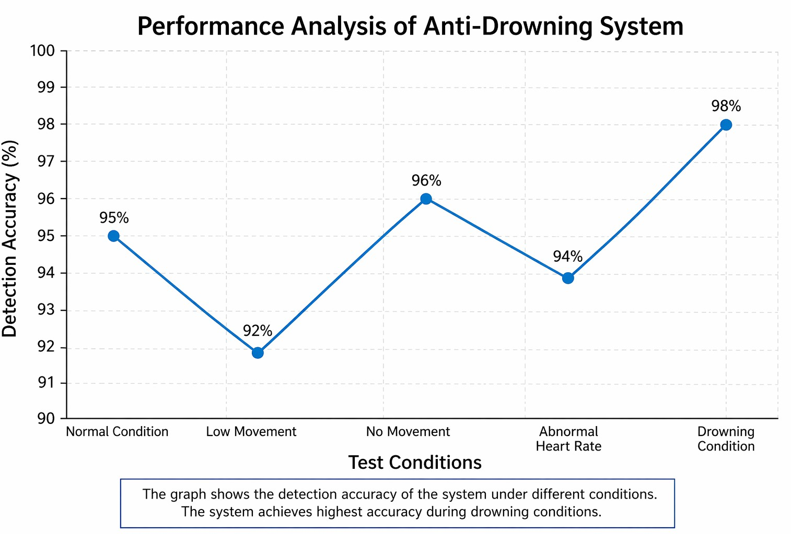

Figure 5: Performance Analysis of Anti-Drowning System

Figure 5 represents the performance analysis of the proposed Anti-Drowning System based on detection accuracy under different test conditions. The graph shows how effectively the system identifies normal and dangerous situations using sensor data. From the graph, it can be observed that the system achieves an accuracy of 95% under normal conditions, indicating stable performance during regular operation. In the case of low movement, the accuracy slightly decreases to 92% due to minor variations in sensor readings. When there is no movement, the accuracy increases to 96%, showing that the system can effectively detect inactivity, which is a key indicator of danger.

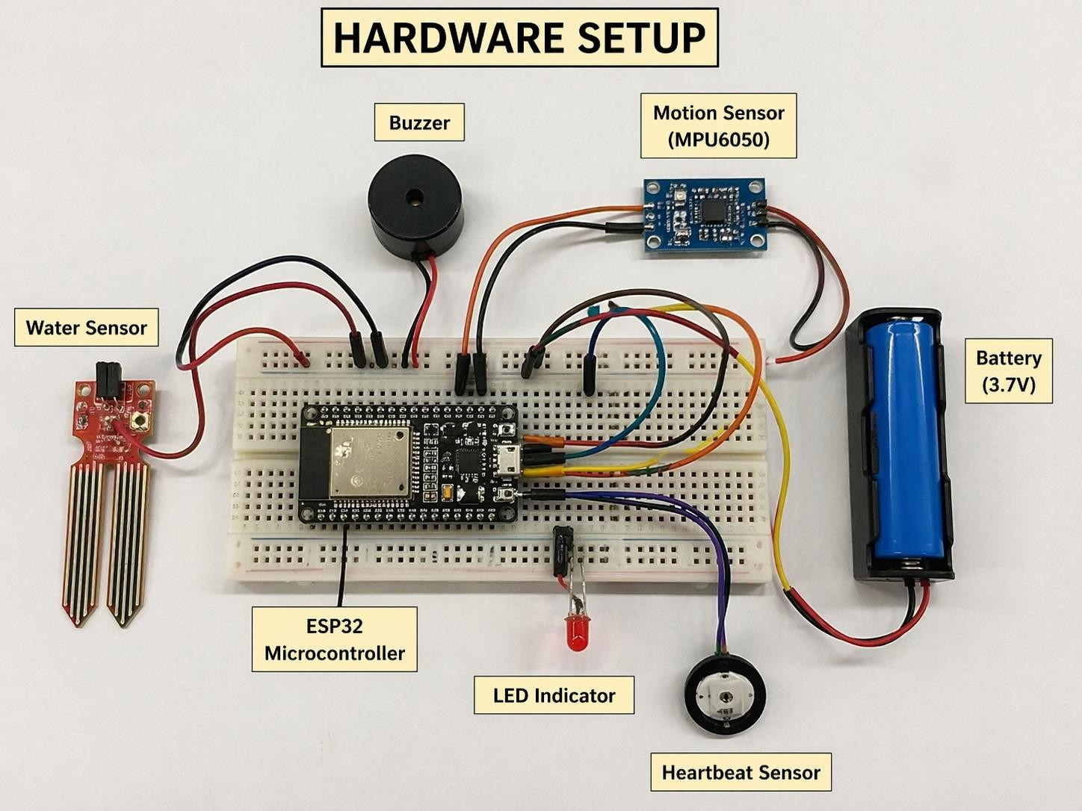

Figure 6: Hardware Setup

The above figure shows the hardware setup of the proposed Anti-Drowning System with Remote Alert. The system is built using an ESP32 microcontroller, which acts as the central processing unit and is mounted on a breadboard for easy connections. A water sensor is connected to the ESP32 to detect the presence of water. It plays a key role in identifying whether the user is in a water environment. A motion sensor (MPU6050) is used to monitor body movement, helping to detect inactivity or unusual motion patterns. A heartbeat sensor is also connected to measure the pulse rate of the user, which helps in identifying abnormal health conditions.

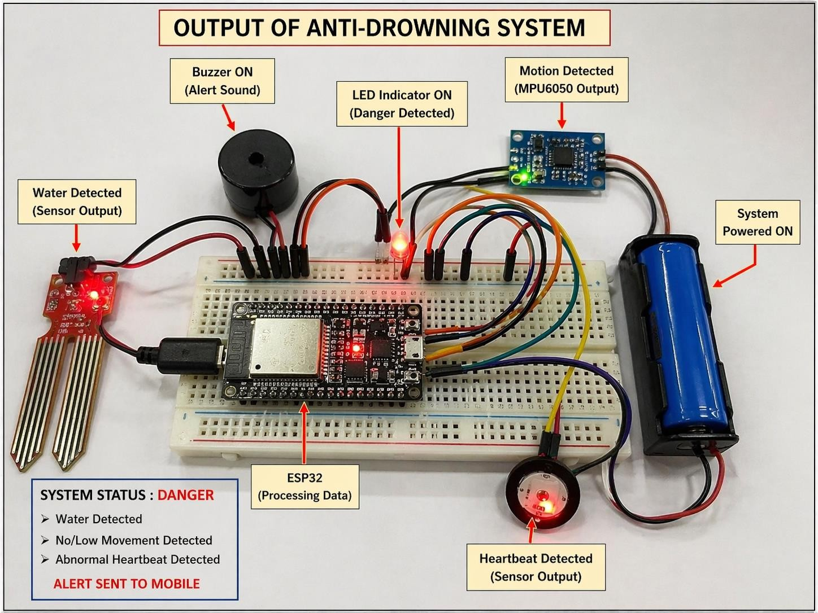

Figure 7: Output of Anti-Drowning System with Remote Alert

The above figure shows the output of the proposed Anti-Drowning System with Remote Alert during a danger condition. The system is in active state and continuously monitors inputs from the connected sensors. From the image, it can be observed that the water sensor detects the presence of water, indicating that the user is in a water environment. The motion sensor output shows reduced or no movement, and the heartbeat sensor indicates abnormal pulse conditions. These combined inputs are processed by the ESP32 microcontroller. Based on the decision logic, the system identifies the situation as a potential drowning condition. As a result, the LED indicator turns ON, representing a danger state. The buzzer is also activated to provide an audible alert, which helps notify nearby people immediately.

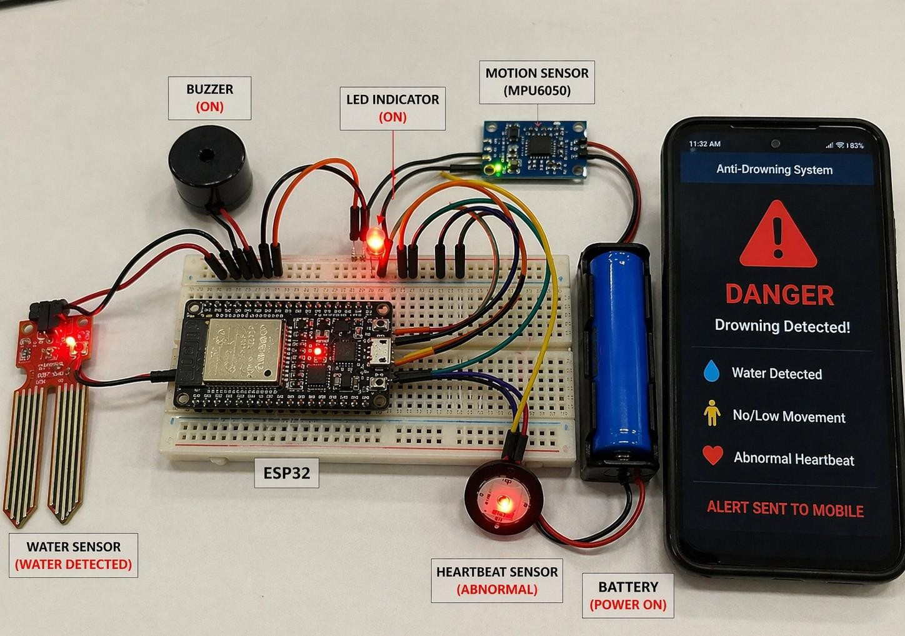

Figure 8: Real-Time Output of Anti-Drowning System with Remote Alert

The figure shows the real-time output of the Anti-Drowning System with Remote Alert. The system is powered ON and all components are actively working. The water sensor detects the presence of water, indicating that the user is in a water environment. The motion sensor identifies low or no movement, and the heartbeat sensor shows abnormal pulse rate. These inputs are processed by the ESP32 microcontroller, which determines that the situation is unsafe. As a result, the LED indicator is turned ON, and the buzzer is activated to provide an audible alert. The system status is displayed as “DANGER,” indicating a possible drowning condition. At the same time, a notification is sent to a mobile device through the Wi-Fi module. The mobile screen displays the alert message along with details such as water detection, no movement, and abnormal heartbeat. This output confirms that the system successfully detects emergency conditions and responds quickly by generating both local and remote alerts, ensuring timely assistance and improved safety.

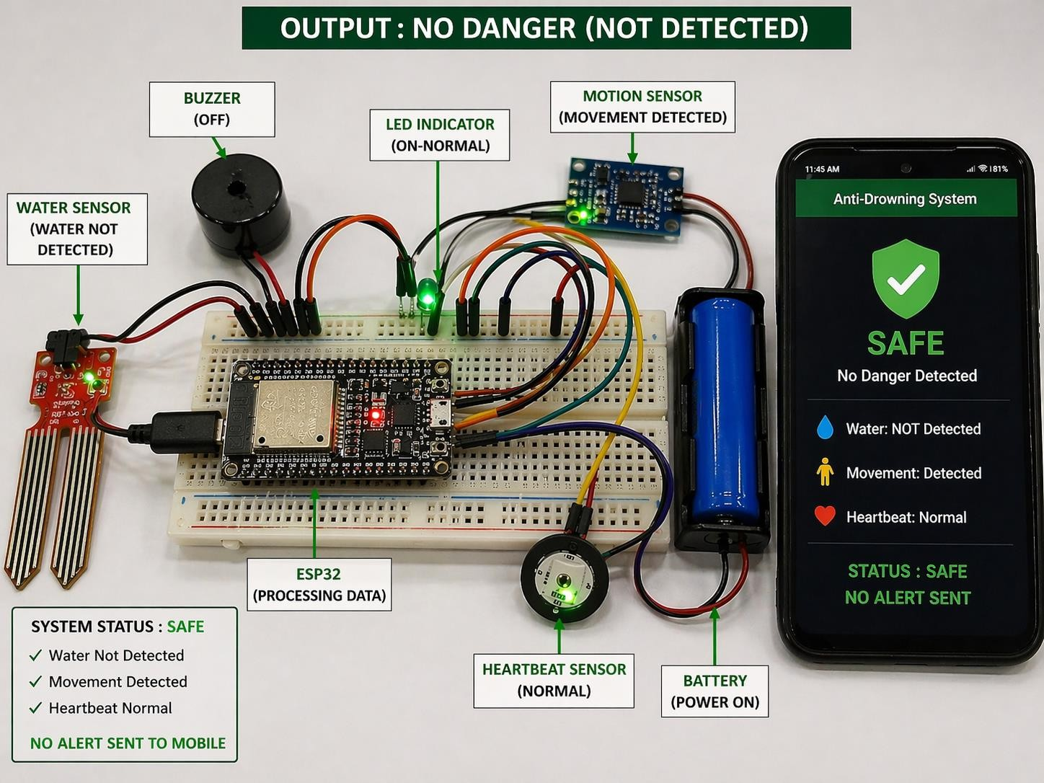

Figure 9:Output of Anti-Drowning System under Normal Condition (No Danger Detected)
The figure shows the output of the Anti-Drowning System under normal (safe) conditions. The system is powered ON and continuously monitors all sensor inputs. The water sensor indicates that no water is detected, meaning the user is not in a risky water environment. The motion sensor detects regular body movement, and the heartbeat sensor shows a normal pulse rate. These inputs are processed by the ESP32 microcontroller, which determines that the situation is safe. As a result, the LED indicator remains ON in normal (green) condition, and the buzzer stays OFF, indicating no emergency. The system status is displayed as “SAFE,” and no alert is triggered. Additionally, the mobile application shows “No Danger Detected,” and no notification is sent. This confirms that the system is functioning correctly under normal conditions without generating false alarms

CHAPTER 7 CONCLUSION
The proposed Anti-Drowning System with Remote Alert has been successfully designed and implemented to enhance safety in water environments. The system effectively uses multiple sensors such as water, motion, and heartbeat sensors to continuously monitor the condition of an individual. By integrating these sensors with the ESP32 microcontroller, the system is capable of processing data in real time and identifying potential drowning situations accurately. The system provides both local and remote alert mechanisms. The buzzer alerts nearby people immediately, while the Wi-Fi module sends notifications to mobile devices, ensuring that help can be provided even from a distance. This combination of features improves response time and increases the chances of rescue. The results and performance analysis show that the system achieves high accuracy, especially during critical conditions, and operates reliably under different scenarios. Although certain limitations such as dependency on sensor accuracy and internet connectivity exist, the overall performance of the system is effective and dependable. In conclusion, the proposed system offers a simple, cost-effective, and efficient solution for drowning detection and prevention. It has the potential to be further enhanced with additional features such as GPS tracking and mobile application integration, making it suitable for real-world applications and improving water safety.

REFERENCE

- J. Smith and A. Kumar, “IoT-Based Smart Drowning Detection System,”
International Journal of Engineering Research, 2020.

- R. Sharma and P. Gupta, “Wearable Sensor-Based Drowning Prevention System,” IEEE Conference on Smart Systems, 2019.
- M. Lee and K. Park, “Real-Time Water Safety Monitoring Using Embedded Systems,” IEEE Access, 2021.
- S. Patel and N. Verma, “Smart Alert System for Drowning Prevention Using IoT,” International Journal of IoT Applications, 2022.
- T. Wang and L. Chen, “Sensor-Based Human Safety Monitoring System,”
Sensors Journal, 2018.
- K. Ramesh and S. Iyer, “Smart Swimming Pool Safety System Using IoT,”
International Journal of Computer Applications, 2021.

- L. Zhang and H. Liu, “Wireless Sensor Network for Drowning Detection,”
IEEE Sensors Conference, 2020.

- P. Singh and R. Kaur, “Real-Time Health Monitoring System Using Wearable Sensors,” International Journal of Biomedical Engineering, 2019.
- A. Johnson and M. Brown, “Embedded System-Based Emergency Alert System,” IEEE Transactions on Embedded Systems, 2018.

- D. Kim and J. Park, “Intelligent Safety Monitoring System Using IoT and Sensors,” IEEE IoT Journal, 2022.
- Espressif Systems, “ESP32 Technical Reference Manual,” 2021.
- Arduino, “Arduino IDE Documentation,” Available: https://www.arduino.cc

- MPU6050 Datasheet, InvenSense Inc., 2018.
- Pulse Sensor Datasheet, World Famous Electronics, 2019.
- Water Sensor Module Documentation, 2020.

- IEEE, “Internet of Things (IoT): A Survey,” IEEE Communications Surveys, 2017.
- WHO, “Global Report on Drowning Prevention,” World Health Organization, 2014.
- N. Kumar et al., “IoT-Based Health Monitoring Systems,” IEEE Access, 2018.
- A. Gubbi et al., “Internet of Things (IoT): A Vision,” Future Generation Computer Systems, 2013.
- R. Want, “An Introduction to IoT,” IEEE Computer, 2015.
- S. Madakam et al., “Internet of Things (IoT): A Literature Review,” Journal of Computer and Communications, 2015.
- J. Yick et al., “Wireless Sensor Network Survey,” Computer Networks, 2008.
- A. Al-Fuqaha et al., “IoT: A Survey on Enabling Technologies,” IEEE Communications Surveys, 2015.

- K. Ashton, “That ‘Internet of Things’ Thing,” RFID Journal, 2009This article introduces the concept of the Internet of Things (IoT) and explains how everyday objects can be connected through the internet for data exchange.
- Microcontroller Programming Guide, Embedded Systems Academy, 2019.This guide provides detailed knowledge about microcontroller programming, including data processing, input-output operations, and control logic.
- Buzzer and Alert System Design Guide, Electronics Hub, 2020.This resource explains the working principle of buzzers and how alert systems are designed in electronic circuits.
- Wi-Fi Communication Protocol Guide, Cisco Networking, 2018.This guide explains how Wi-Fi communication works, including data transmission, protocols, and network connectivity
- Cloud Computing Basics, IBM Documentation, 2021.This helped in understanding how alert data can be sent and accessed remotely.
- Mobile Application Development Guide, Google Developers, 2022.This guide provides information about developing mobile applications and implementing notification systems.
- Safety Monitoring Systems, Springer Publications, 2020.It explains techniques for detecting abnormal conditions and triggering alerts

APPENDIX-I COADING

#include <WiFi.h>
#define WATER_SENSOR 34
#define HEART_SENSOR 35
#define MOTION_SENSOR 32
#define BUZZER 25
#define LED 26

const char* ssid = "Your_WiFi_Name";
const char* password = "Your_WiFi_Password";

int waterValue = 0; int heartValue = 0; int motionValue = 0;

void setup() { Serial.begin(115200);
pinMode(WATER_SENSOR, INPUT); pinMode(HEART_SENSOR, INPUT); pinMode(MOTION_SENSOR, INPUT); pinMode(BUZZER, OUTPUT); pinMode(LED, OUTPUT);

digitalWrite(BUZZER, LOW); digitalWrite(LED, LOW); WiFi.begin(ssid, password);

Serial.println("Connecting to WiFi...");
while (WiFi.status() != WL_CONNECTED) { delay(1000);
Serial.println("Connecting...");
}

Serial.println("WiFi Connected");
}

void loop() {
waterValue = analogRead(WATER_SENSOR); heartValue = analogRead(HEART_SENSOR); motionValue = analogRead(MOTION_SENSOR);

Serial.print("Water Sensor: "); Serial.println(waterValue); Serial.print("Heart Rate: "); Serial.println(heartValue);

Serial.print("Motion Sensor: "); Serial.println(motionValue);

// Condition for danger detection
if (waterValue > 500 && motionValue < 100 && heartValue < 60) { Serial.println("DANGER: Possible Drowning Detected!");

digitalWrite(BUZZER, HIGH); digitalWrite(LED, HIGH);

// Remote alert simulation
Serial.println("Sending Remote Alert to Mobile...");
}
else {
Serial.println("SAFE: Normal Condition");

digitalWrite(BUZZER, LOW); digitalWrite(LED, LOW);
}

delay(2000);
}

